Web Instruction: Using a Virtual Microscope

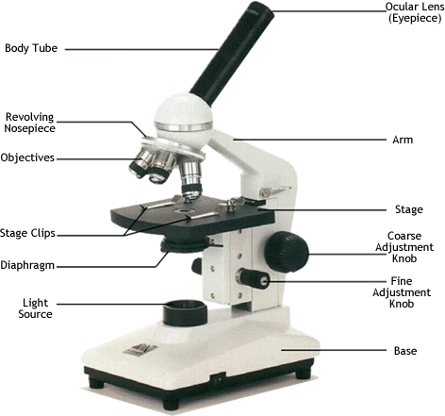
In the previous classroom lesson, you identified the parts of a
microscope and learned the step-by-step procedure for properly using a
microscope. In this lesson, you will test your skill by practicing what
you have learned about the careful operation of the microscope.

Before you begin, make sure your headphones are plugged in and on your head.
Go to http://www.udel.edu/biology/ketcham/microscope/scope.html
Part 1
Looking At The Microscope
Click on start tour, then follow the directions of the narrator. As he pauses, answer the questions below. Remember: this is a step-by-step guide for proper operation.
Notice the checklist follows the sequence of steps.

Step 1-Turn on the Light
What do you even need to do before you turn the light on? ________________________

Step 2-Set the Rheostat at 10
On our classroom microscopes, we don’t have a rheostat but you can adjust the amount of light going in by the lever or wheel on the stage.

Step 3-Pick a slide (select “letter e” slide)
Which objective lens do you always start with when you are looking at a slide? __________

-Make sure the scanning (4X) lens is in place

Step 4-Center the specimen
-On some microscopes you will have to move the slide manually and on others there will be dials to turn to move the slide forward and back, and side to side.

Start stage questions:
A. Should the stage be as high as it can be or
as low as it can be when you begin to focus? ______________________________
B. Are you turning the coarse focus (large knob)
or fine focus (small knob) first? _______________________________________
Part 2
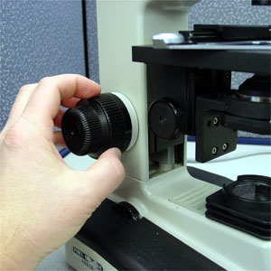
Time to switch views. Click on the switch views button on the
upper left so that you are: Looking Through The Microscope

Step -Adjust oculars
We don’t have adjustable oculars on our classroom microscopes.

Step 5-Adjust Coarse Focus
Which power should be set when adjusting coarse focus? Low? Medium? High?

Step 6-Fine Tuning
-Don’t forget to adjust the slide so that it is in the very center at the tip of the pointer.
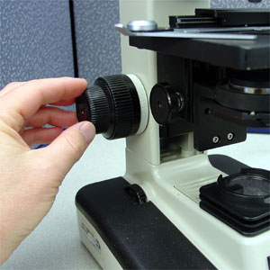
-If the “e” is not in the very middle of the view, use the dials at 4:30 to position the “e” so it right in the center.
-Tweak the fine focus knob
-Adjust the iris diaphragm

Step 7-Switch Objective Lenses
-Make sure that what you want to look at is at the end of the pointer.
-It is often necessary to re-adjust both the fine focus knob and
the _____________________ after switching objective lenses.

Work your way through each of the objectives, one at a time, adjusting the fine focus only.
-Never turn the coarse focus knob when you are on anything above the lowest power.

If the object you want to look at is no longer visible in the center under high power, go back to 4X (or the lowest power) and adjust the slide so you can see it under high power.
Part 3
Now go back and choose a different slide. Then follow the steps to the highest magnification and draw what you observe in the field of view in the circle below. Repeat with another sample.

Name of slide: _________________ Name of slide: ___________________

Magnification: ______X Magnification: ______X
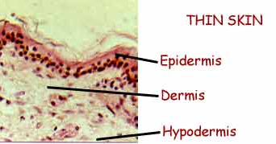

Label anything interesting you see by drawing a line
from the object to outside the circle and write
the label outside of the circle.

