Name______________________________________ Period_________
Size and Shapes of Cells
THE SURFACE AREA TO VOLUME RATIO OF A CELL
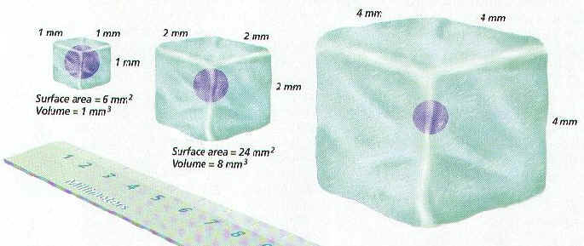
INTRODUCTION:
Cells are limited in how large they can be. This is because the surface area and volume ratio does not stay the same as their size increases. Because of this, it is harder for a large cell to pass materials in and out of the membrane, and to move materials through the cell.
In this lab, you will make cube shaped models to represent cells. The dimension along one side will be doubled with each model. You will then calculate the surface area, volume, and the ratio between the two.
Surface Area : Volume Ratios
Surface Area (SA)= length x width x number of sides (=6)
Volume=length x width x height
Ratio of Surface Area to Volume=Surface Area/volume

Directions:
- Count out 36 sugar cubes. Each cube represents 1 centimeter (cm) x 1cm x 1cm.

- Examine a single cube. (KEEP THIS CUBE SEPARATE)
  - What is its surface area?
  - What is its volume?
  - What is its surface area to volume ratio?

- Make a cube that is 2cm x 2cm x 2cm. (KEEP THIS CUBE SEPARATE)
  - What is its surface area?
  - What is its volume?
  - What is its surface area to volume ratio?

- Make a cube that is 3cm x 3cm x 3cm. (KEEP THIS CUBE SEPARATE)
  - What is its surface area?
  - What is its volume?
  - What is its surface area to volume ratio?

- Compare the ratios of each of the cubes.
  - Look at the three cubes you constructed. If these represented the size of three different living cells, how would the size of the cells affect their functioning?

DATA TABLE: CELL SIZE COMPARISON
Dimensions | Surface Area  LengthxWidthx6 | Volume  LengthxWidthxHeight | Surface Area to Volume Ratio
1cmx1cmx1cm
2cmx2cmx2cm
3cmx3cmx3cm
QUESTIONS:
- Which model has the largest surface area?

2. Which model has the largest volume?
3. Which model has the largest ratio?
4. To maintain life, and carry-out cellular functions, materials must be able to move into and out of the cell. Also, material needs to be able to move within the cell. What might be the advantage of having a large surface area?

5. What might be the disadvantage of having a large volume?

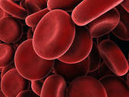
6. This is a picture of a red blood cell. How would its shape improve cell function?

Adapted from Wood, B. S., Lecture Free Teaching in Seven Steps, The American Biology Teacher, Volume 67, No. 6, August 2005, and http://www.biologyjunction.com/cell_size.htm

