Name:________________________________________ Date:_________________________ Period:_________
Life Science Photosynthesis & Cellular Respiration
Directions: Follow the prezi at http://prezi.com/thsuoroaapkr/photosynthesis-and-cellular-respiration/ and answer the questions below.
Photosynthesis
What type of cell is photosynthesis occurring in? __________________________________

What cell part controls process of photosynthesis?______________________________________

In your own words, what is photosynthesis?_______________________________________________________ __________________________________________________________________________________________________ __________________________________________________________________________________________________
Fill in the 5 blanks in the diagram below to show the process of photosynthesis:
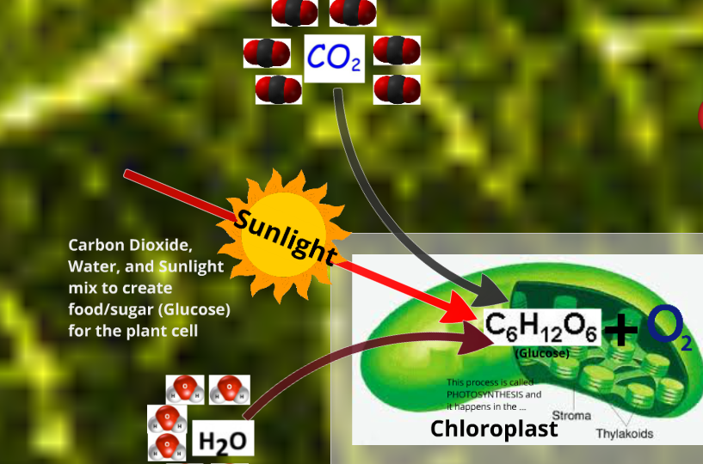

What is the reaction for photosynthesis?

How many molecules of Carbon Dioxide are used?_______________
How many molecules of Water are used? _____________
What is type of food is made and how many molecules?________________________ & _______________
How many molecules of Oxygen are made?______________
What happens to the oxygen made from photosynthesis? _______________________________________ _________________________________________________________________________________________________ _________________________________________________________________________________________________
What happens to the glucose after photosynthesis? (little tricky – two parts to this answer)____________ __________________________________________________________________________________________________ __________________________________________________________________________________________________
Cellular Respiration
What cell part controls the process of cellular respiration? _____________________________________

In your own words, what is cellular respiration? ____________________________________________________ _________________________________________________________________________________________________ _________________________________________________________________________________________________
Fill in the 5 blanks in the diagram below to show the process of cellular respiration:
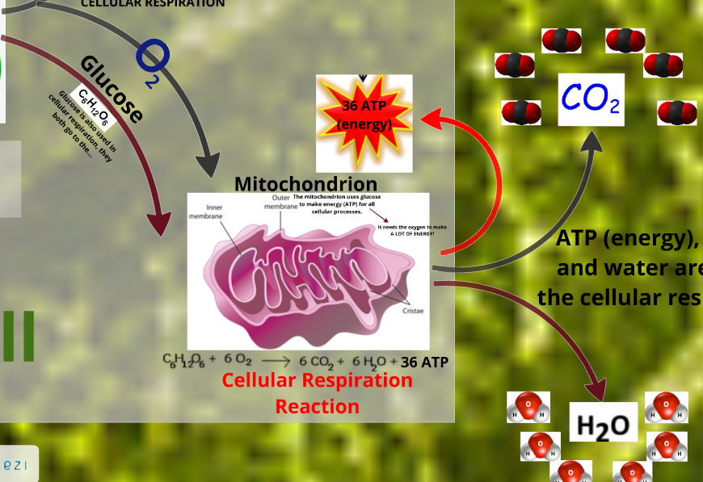

Why does the mitochondrion need oxygen?_________________________
_________________________________ _________________________________
How many molecules of oxygen are used? ________________
How many molecules of glucose are used? ________________
How many molecules of carbon dioxide are made? ____________
How many molecules of water are made? _______________
How many molecules of energy are made? _______________
What are they called? ___________

What is the reaction for cellular respiration?

Do plants (or any other organisms that use photosynthesis) need animals/humans to live? Provide evidence. _____________________________________________________________________________ ________________________________________________________________________________________________________________________________________________________________________________________________________________________________________________________________________________________________

