Life Science Eukaryotic Cells – Microscope Investigation

Name ___________________________________________________ Date: Class:

Background Information: As we’ve already seen, there are many differences between Prokaryotic cells (bacteria) and Eukaryotic cells (animal & plant cells). When we look at the structures of the two types of Eukaryotic cells there are many similarities, but there are some differences between animal and plant cells that should be noted. To be prepared for this microscope lab, you must be familiar with the cell parts that animal and plant cells have in common and parts that are unique to each. Record those cell parts below.
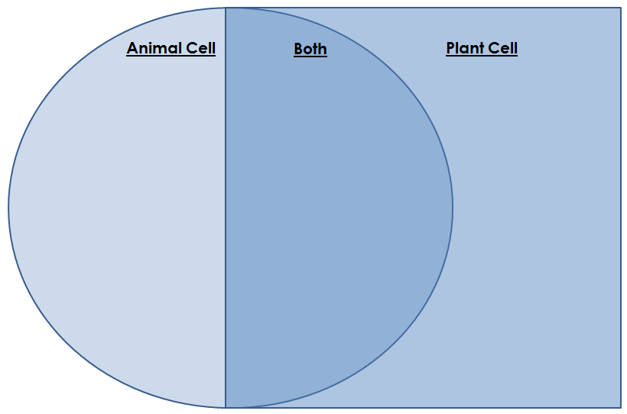
Today, you will be doing a microscope investigation of animal and plant cells. It is up to you determine which cells are animal and which are plant, based on the cell structures you see for each specimen. Be sure to make detailed drawings in the field of view circles below and label any cell parts as evidence to support your ideas.

- Object: ____________________ 2. Object: _____________________ 3. Object: ____________________

Total Magnification: ____________ Total Magnification: ___________ Total Magnification: __________

4. Object: ____________________ 5. Object: ___________________ 6. Object: ___________________

Total Magnification: ____________ Total Magnification: ___________ Total Magnification: __________
Discussion & Conclusion

In the area below, analyze the results of this lab using the data from your drawings above and your Venn diagram comparing animal and plant cells. This paragraph should be a minimum of ten sentences and include all of the requirements in the list below.
While analyzing, make sure you:
- Describe what happened in the investigation and include results from the data
- Describe what factors influenced the results (explain why the data turned out the way it did)
  - Include scientific knowledge or ideas that apply to the experiment and BE SPECIFIC
- Were there any errors made during the experiment?
  - Explain how the experiment could be improved the next time to help minimize sources of errors.
- Finish the paragraph with a concluding sentence that sums up the results of the experiment.

________________________________________________________________________________________________________________________________________________________________________________________________________________________________________________________________________________________________________________________________________________________________________________________________________________________________________________________________________________________________________________________________________________________________________________________________________________________________________________________________________________________________________________________________________________________________________________________________________________________________________________________________________________________________________________________________________________________________________________________________________________________________________________________________________________________________________________________________________________________________________________________________________________________________________________________________________________________________________________________________________________________________________________________________________________________________________________________________________________________________________________________________________________________________________________________________________________________________________________________________________________________________________________________________________________________________________________________________________________________________________________________________________________________________________________________________________________________________________________________________________________________________________________________________________________________________________________________________________________________________________________________________________________________________________________________________________________________________________________________________________________________________________________________________________________________________________________________________________________________________________________________________________________________________________________________________________________________________________________________________________________________________

