Name: _________________________________________
- What is ecology?
____________________________________________________________________________________________________________________________________________________________
- LEVELS OF ORGANIZATION
- A single member of a species is known as an _________________________.
- ________________________ are groups of individuals.
- ________________________ are grouping of different populations.
- An _____________________ includes a community and its surroundings.
- A ____________________ is a group of ecosystems with the same type of climate.
- A ______________________ would be the entire planet.
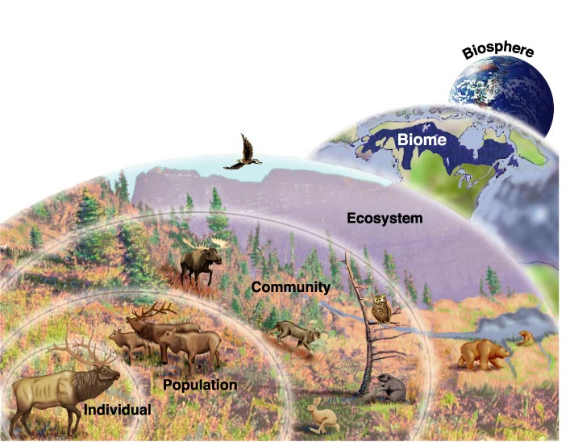
- PRODUCERS
Q: What do we call organisms that make their own food?
A: _________________
Q: What process do plants undergo to make their own food?
A: _________________
Q: What’s the equation for photosynthesis?
A: _________________________________________________
- CONSUMERS
Q: What do we call an organism that consumes its food?
A: _________________
- There are four types of heterotrophs, depending on where the organism’s energy (i.e. food) comes from:
  - _________________
  - _________________
  - _________________
  - _________________
Q: Where does a carnivore get its energy?
- A: From _________________ only
Q: What are some examples of carnivores?
- A: _________________________________________________
Q: Where does an omnivore get its energy?
A: From both _________________ and _________________/grains/fruit, etc
Q: What are some examples of omnivores?
A: __________________________________
Q: Where does a decomposer get its energy?
A: From breaking down ______________________________
Q: What are some examples of decomposers?
A: ________________________________________________
- FOOD CHAINS
- Energy flows through an ecosystem in ________________ _________________, from the sun or inorganic compounds to autotrophs (producers) and then to various heterotrophs (consumers)
- Energy is transferred by organisms _________________ and __________________________________
- Energy transfer is represented by _________________ going in the ______________________________________
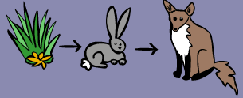
- FOOD WEBS
- A _________________ links all the food chains in an ecosystem together
- More _________________ interactions than unidirectional flow of food chains
- In reality, the interactions between _________________ and _________________ in an ecosystem’s exists as a _________________ instead of a food chain

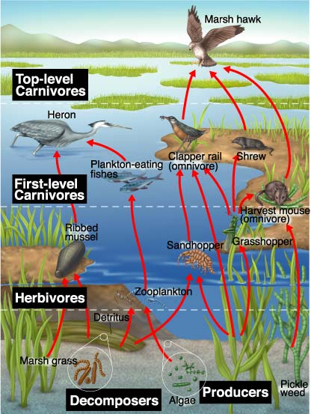

- ENERGY PYRAMIDS
- Each step in the food chain is called a ________________ _________________
Amount of energy available in this tropic level

- _________________ are the _________________ trophic level
- _________________ make up the second, third or higher trophic level
Energy pyramid – only _________ of energy is transferred from one trophic level to the next
Energy is used up by the organism’s _________________ and/or released as _________________

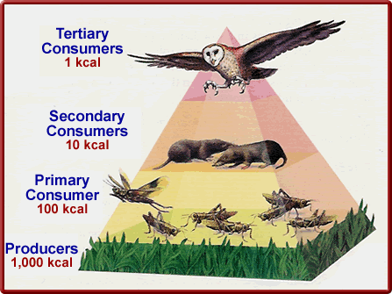
- BIOTIC VERSUS ABIOTIC
- _________________ factor –influences/interactions of _________________ organisms
- _________________ factor – physical, _________________ influence that affect an ecosystem
Q: What are some biotic factors that affect a forest?
A: _____________________________________________________
Q: What are some abiotic factors that affect a forest?
A: _____________________________________________________
- COMMUNITY INTERACTIONS
- Competition
- Predation
- Symbiosis
  - Mutualism
  - Commensalism
  - Parasitism
- Competition
- Definition – organisms of the same or different species attempt to use the _________________________________
- __________________________________ principle – no two species can occupy the same _________________ in the same habitat at the same time; one species will _________________ the other
- Niche – range of _________________ and _________________ conditions in which an organism _________________ and the way in which the organism _________________ those conditions
- Predation
- Definition – one organism captures and _________________ on another
- Predator _________________, prey does not.

- Symbiosis
- Definition ________________________________________ between two organisms
- There are 3 kinds:
  - _________________
  - _________________
  - _________________

- POPULATION GROWTH
Three factors affect population size
1. Number of _________________
2. Number of _________________
3. Number of individuals that enter or leave pop.
    - Immigration – __________________________________
    - Emigration – __________________________________

- Exponential Growth
- Under ideal conditions with unlimited resources, a population will grow _______________________________.
- Logistic Growth
- As resources become _________________, the growth of a population slows or stops
- ___________________________(K) – largest number of _________________ a given environment can support
- Once the population reaches its carrying capacity, the population size _____________
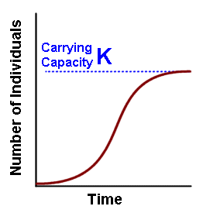

- Coevolution
Definition- a long term change that takes place in two species because of their _______________________________with one another.

