Name ______________________________________ Period __________ Date ___________

**Chargaff’s DNA Data**

**Introduction**

DNA was first discovered in 1869, but not much was known about the molecule until the 1920s. Early researchers discovered that DNA was comprised of repeated units called nucleotides. Each nucleotide contains a part called a ***nitrogenous base***. There are four different nitrogenous bases found in DNA:

*Adenine* ***(A)***

*Cytosine* ***(C)***

*Guanine* ***(G)***

*Thymine* ***(T)***

In the 1920s it was believed that these nitrogenous bases occurred in all living things in the same repeated pattern, such as ATGC ATGC ATGC. If this were true, then DNA could not be the genetic material. With the same repeated pattern in all species, DNA could not provide the variety needed for a molecule containing the genetic code.

After World War II, the biochemist Erwin Chargaff made some major discoveries about the nitrogenous bases in DNA. His research revealed the percentage of each base (A, T, G, and C) found in an organism’s DNA. Table 4.2 below includes some of Chargaff’s data and some more recent additions.

|  |  |  |  |  |
| --- | --- | --- | --- | --- |
| **Table 4.2. Nitrogen Base Make-Up of Different Organisms’ DNA (in Percentages)** | | | | |
| **Organism** | **A** | **T** | **G** | **C** |
| *Mycobacterium tuberculosis* | 15.1 | 14.6 | 34.9 | 35.4 |
| Yeast | 31.3 | 32.9 | 18.7 | 17.1 |
| Wheat | 27.3 | 27.1 | 22.7 | 22.8 |
| Sea Urchin | 32.8 | 32.1 | 17.7 | 17.3 |
| Marine crab | 47.3 | 47.3 | 2.7 | 2.7 |
| Turtle | 29.7 | 27.9 | 22.0 | 21.3 |
| Rat | 28.6 | 28.4 | 21.4 | 21.5 |
| Human | 30.9 | 29.4 | 19.9 | 19.8 |

**Analysis**

1. What observations can you make about the data in the table? What patterns do you notice?

____________________________________________________________________________________________________________________________________________________________________________________________________________________________________________________________________________________________________________________________________________________

1. Using your observations from table 4.2, predict the unknown percentages for each base and complete the chart below.

|  |  |  |  |  |
| --- | --- | --- | --- | --- |
| **Table 4.3 Nitrogen Base Percentages for Unknown Organisms** | | | | |
| **Unknown Organism** | **A** | **T** | **C** | **G** |
| Organism #1 | 32 |  |  |  |
| Organism #2 |  |  | 22 |  |
| Organism #3 |  | 30 |  |  |
| Organism #4 |  |  |  | 3 |

1. Using data from tables 4.1 and 4.2, determine unknown organisms 1-4.

#1

#2

#3

#4

1. What does the data show about the make-up of DNA for different species? Explain.

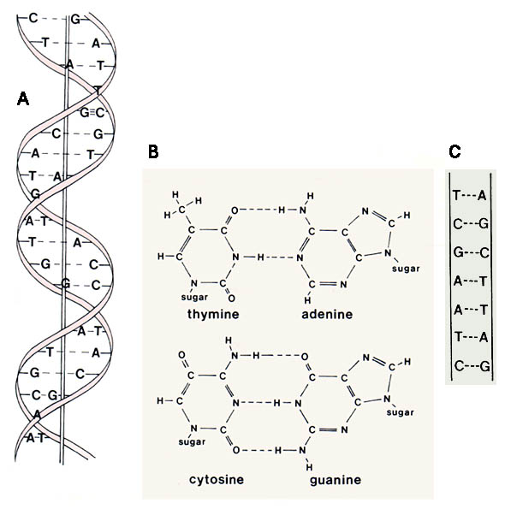____________________________________________________________________________________________________________________________________________________________________________________________________________________________________________________________________________________________________________________________________________________

**Piecing it Together** - Chargaff’s data was a central piece of evidence used by James Watson and Francis Crick in 1953 to successfully describe the structure of DNA. Look at the drawing of DNA to the right.

1. What do you notice about the arrangement of the nitrogen bases? Record as many observations as you can.
2. How do you think Chargaff’s data helped Watson & Crick to predict that DNA looks like this?

