Name________________________________ Number________

The Cell Cycle

Why do cells reproduce asexually?

1. _________________ 2. _________________ 3. _________________

Stage I- Interphase

*

*

*

*

Late Interphase
*

*

*

Stage II- Mitosis

Phase 1- Prophase
*

*

*
Phase 2- Metaphase

*

Phase 3- Anaphase

*

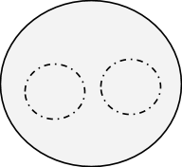
Phase 4- Telophase

*

*

*

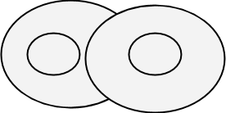
Stage III- Cytokinesis

*

*

